|  |  |  |
| --- | --- | --- |
| Display Ad Ecosystem  MSFT Display Ad team induction | | July 18  2014 |
| <Document Abstract> |  | |

|  |  |
| --- | --- |
|  |  |
|  | DO THE MATH |

Contents

1.Microsoft Display overview 3

1.1Browse: Overview 4

1.1.1 Supply side 5

1.1.2 Demand Side 6

1.1.3 MSFT as Ad Network 8

Section 2.1 Overview 9

2.1.1 ADVERTISER PROCESS 10

2.1.2 PUBLISHER PROCESS 12

2.1.3 AD EXCHANGE PROCESS 12

2.1.4 Introduction 14

2.1.5 Ad Exchange 15

2.2 Demand Side 18

2.2.1 Demand Side Platform (DSP) 18

2.2.2 Data Management Platform 18

2.2.3 Planning & Attribution 20

2.2.4 Agency Trading Desk 21

2.2.5 Dynamic Creative Optimization (DCO) 21

2.2.6 Advertising Agency 22

2.2.7 Advertiser’s Ad server 23

2.3 Supply Side 25

2.3.1 Supply Side Platform (SSP): 25

2.3.2 RTB 26

### Section 1

Microsoft Display Advertising Overview

Line of Business

* Browse
* AIA
* Mobile

## Section 1.1hg

* Browse
  + Supply side
  + Demand side
  + MSFT as an Ad Network

## Section 1.1.1

* Supply side
  + O & O
  + 3P
  + SSP

## Section 1.1.2

* Demand side
  + Brand
  + Audience
  + Performance

## Section 1.1.3

* MSFT as Ad network
  + Ad Expert
  + MSFT Ad Exchange
  + AMAN

# Line of Business

Microsoft display advertising deals basically in three segments:

1. Browse

This segment pertains to the display ads that appear in the various websites opened through PC based browsers

1. Ads in Apps (AIA)

All the ads that are displayed in the home apps of Microsoft are coined as AIA

1. Mobile

This segment refers to the mobile platform, i.e. mobile phones or tablets. It is further divided into:

* 1. AIA (Ads in Apps)
  2. Browsers

# 1.1Browse: Overview

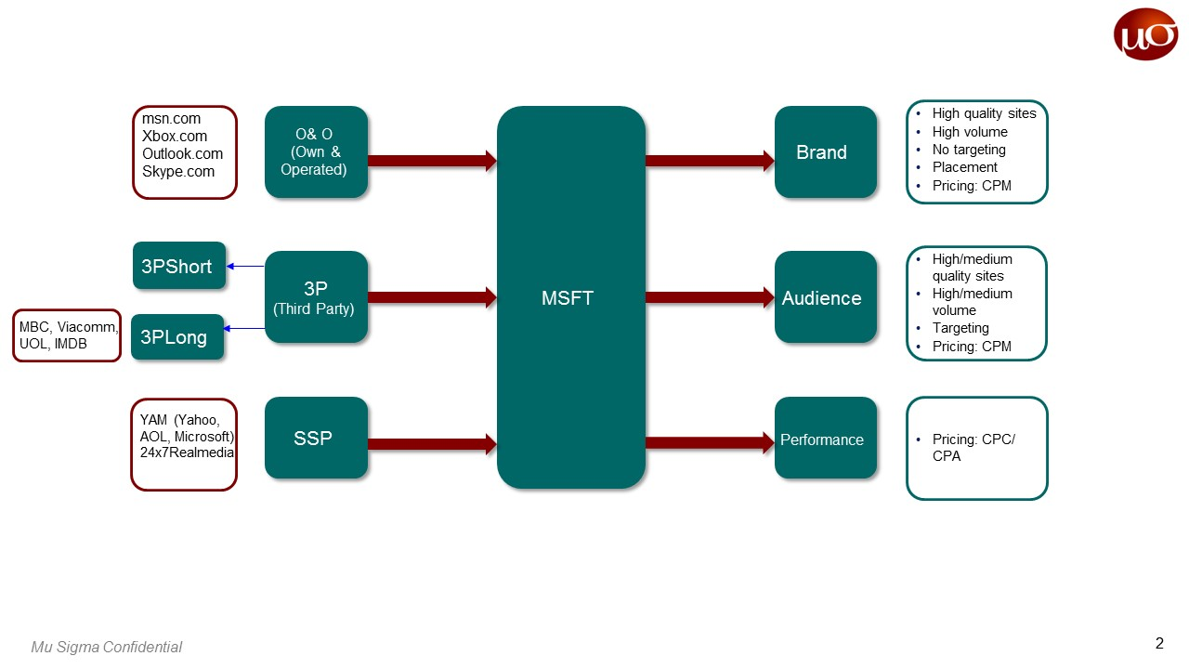

## 1.1.1 Supply side

Impression is the product here. Impression, sometimes called a view or an ad view, is a term that refers to the point in which an ad is viewed once by a visitor, or displayed once on a web page. The supply side of display advertising provides the inventory of impressions of various publishers.

MSFT sells impressions to advertisers/marketers which are its own impressions or those of other publishers. Based on the source of impressions, the supply side is divided into:

* O&O (Own & Operated)
* 3P (Third Party)
* SSP (Supply Side Platform)

#### O&O:

The impressions belong to MSFT owned websites, i.e. MSFT is the publisher. No cost is incurred in this case apparently.

#### 3P:

Impressions of other publishers are sold through MSFT. This is done through partnerships or contracts with third party publishers. The contracts can either be short term or long term:

* 3P Short: Generally weekly deals are made
* 3P Long: Contract for more than a year is made. These publishers are generally trusted partners with which MSFT renews the contracts. MBC, Viacomm, UOL and MDB are the main 3PL partners of MSFT.

Cost incurred is basically split or shared between the partner sites and MSFT. This is called RevShare.

#### SSP:

Impressions bought through Supply Side Platform fall under this category. These impressions are acquired through RTB (Real Time Bidding).

* An alliance is formed between Yahoo, AOL and Microsoft to form a mini ad exchange to manage inventories amongst the three.
* 24x7 RealMedia is one such SSP through which MSFT acquires impressions

Impressions are bought by MSFT from the publishers in terms of Traffic Acquisition Cost (TAC).

## 1.1.2 Demand Side

This is basically the advertiser/marketer side who demands for ad impressions/inventory of impressions. MSFT sells impressions to these advertisers depending on the requirements of the advertisers.

Based on the requirements of the marketers impressions are classified as follows:

* Brand
* Audience
* Performance

#### Brand:

Marketers requiring brand awareness through ads generally demand for the following attributes (ideally):

* High quality websites:

Ads need to be shown on trusted and popular websites.

* High volume of impressions:

Since large audiences need to be targeted high volumes of impressions are needed and no specific targeting is required.

* Placement of ads:

Ad placement which increases viewability is crucial for brand awareness.

Pricing is done on the basis of CPM (Cost per Mille) and the impressions sold are reserved in this case

#### Audience:

Marketers wishing to target particular segments of audience require impressions with the attributes (ideally):

* High to medium quality websites
* High to medium volume of impressions
* Targeting:

Advertisers can zero in on specific segments of the audience (prospective customers) for effective advertising. This can be done in many ways. MSFT offers the following ways as products:

* + Remessaging (similar to retargeting)

Targeting the viewers based on the viewer behavior

* + Profiling

Customer profile used for targeting

* + CDT (Customer Data Transparency)

Customer data is used for targeting

* + CPGOE (Consumer Product Goods Online Effect)

Offline purchasing data of customers is used for targeting

Pricing is done on the basis of CPM (Cost per Mille) and the impressions sold are reserved in this case as well.

#### Performance:

Few marketers may also choose to purchase impressions on the basis of their performance like number of clicks and similar actions. The advertiser in this case is billed on CPC (Cost Per Clicks) or CPA (Cost Per Action).

This usually done with remnant inventory (leftover inventory) due to the apparent risk incurred on MSFT. These impressions are unreserved.

* Overall profit earned by MSFT can be calculated as follows:

Profit = (CPM x Number of impressions - TPM x Number of impressions)/1000

## 1.1.3 MSFT as Ad Network

Microsoft display advertising in browse business works through basically three platforms:

1. Ad Expert
2. MSFT Ad Exchange (through AppNexus)
3. AMAN

Advertisers with different inventory needs classify the platforms. Generally advertisers place an order consisting of a number of order items where in the particulars of the required ad impression are specified. Order falls into the following advertiser hierarchy:

#### Advertiser hierarchy

Parent Advertiser

*(P&G)*

Advertiser

*(P&G UK)*

Campaign

*(Dove)*

Order

*(Dove soap)*

Order item

*Point where impression specifics are considered*

##### 1.1.3.1 Ad Expert

Ad Expert is Microsoft’s premium ad network that serves advertisers with high quality inventory and guaranteed delivery through preordering. This is the platform through which MSFT sells its premium ad inventory. The order item consists of the following advertiser requirements:

* Impressions goal

The target impressions to be delivered by MSFT

* Start & end date

The tenure of the campaign for which the impressions need to be served

* Booking level

The level at which the advertiser chooses to place the order, i.e. mentioning the placement/site/exchange where his ad should appear

* Opt out

The advertiser could also choose as to where the ad should not appear

* Frequency capping & similar options

Options as to how many times an ad should appear in a day or the sequence through rotation, etc.

* Target audience

The audience by whom the ad must be viewed

* CPM

The cost per mille at which these impressions are sold (varies with the order)

#### Booking level

*Granularity increases*

*Price increases*

1. Run of terminal location

Exact location on a page as to where the ad must appear

1. Run of site

The specific websites on which the ad must appear

1. Run of channels

Sports/music/entertainment etc.

1. Run of network

The network of publishers on which the ad may appear

Similarly, advertisers can opt out of specific placements, sites, etc.:

#### Opt out levels

1. Placement
2. Site
3. Publisher
4. Exchange/network
5. IAB category

This demand is met by matching the particulars of the inventory in the following **priority of supply chain**:

Own & Operated

Third Party (Long term deal) – 3PL

Third Party (Short term deal) -3PS

Third Party Programmatic – 3PP (YAM, 24x7)

And the following order of acquisition is followed for collection the demanded ad inventory:

Procurement

(O&O, 3P, 3PP)

Deal

(Long term/short term)

Publisher

Site

Placement

(Control placement/ terminal location/ primary scripting code)

Often due to the granularity of specifications the demand is not met by the available inventory and despite acquiring inventory from all three levels (O&O, 3P, 3PP) supply falls short. In this case MSFT bears the penalty of delivering the remainder goal of impressions free of cost and sometimes offers bonus inventory. It is coined as Make Good to maintain customer relationship.

##### 1.1.3.2 Microsoft Ad Exchange

While the demand is not always met by the inventory there is always surplus inventory that is not consumed by the demand side. This surplus inventory is sold through AppNexus by allowing advertisers to bid for impressions – Real Time Bidding. MSFT provides a platform called MSFT Ad Exchange (MAX) through which RTB can take place. AppNexus is a very large ad exchange which rarely falls short of inventory. Though targeting cannot be achieved to the level provided by AdExpert, targeting can be done to an extent depending on the inventory available through MAX.

##### 1.1.3.3 Ad Market AppNexus (AMAN)

AMAN is an ad network, which acquires ad inventories from AppNexus via 3PA (third party AMAN). Moreover the surplus from MAX is also given to AMAN. AMAN is a platform which does not give guarantee to the advertiser. Advertisers with a small budget and who are willing to take a low quality impression acquire the impression. Advertisers use CPC, CPA and CPM as the standard of pricing to acquire the inventory. The remnant inventory available even after buys from AMAN becomes a place for House ads, i.e. MSFT ads.

The order items of AMAN are

* Budget
* Start date
* End date
* CPM/ CPA/ CPC
* Targeting

**Ad Inventory flow in MSFT**

Ad Expert

*Surplus inventory*

AppNexus|MAX

AMAN

AppNexus

3PA

House ads (MSFT ads)

Section 2: Display Advertising

# Section 2.1

Overview

# Section 2.2

Demand side

# Section 2.3

Supply side

2.1 Ad ecosystem overview

2.3 Sales info

2.2. User data

2.1. User data

1.1 User clicks on the URL

1.2 Request ad

Display ad

1.3 Provide Ad / Redirect to Ad Exchange

1.14. Winning DSP ad

3.1 Retrieves data

1.13 Provide winning advertiser after 2nd RTB

1.4 Request for Ads

1.5 Forwards ad request

1.12Provide winning advertiser

3.2 Sends data

1.6 Request for advertiser

1.11 Ads Info.

1.7 Request for Ad data

1.8 RTB

3.3 Sends aggregated info.

4.1 Displayed Ad info

4.2 Retargeting data

## 2.1.1 ADVERTISER PROCESS:

1.9 Media of Ad display

1.10 Ad inventory

Unify data (CRM, market, website and third party data) in DMP

Build audience segments (in DMP)

Create advertising plan (to reach target audience)

Budget (creation and development of digital ad campaign)

Design advertisement (different media formats and devices)

ADVERTISE (using DSPs and technology for buying media)

Optimize and analyze campaign

Acquire ad inventory (portal, blogs, websites, online portfolios, etc.)

Update DMP for retargeting (future plans)

## 2.1.2 PUBLISHER PROCESS:

Publisher Ad Server connects to the Ad Exchange for receiving ads

## 2.1.3 AD EXCHANGE PROCESS:

Displays winning ad and signals the same to DSP

Receives winning ad from Advertiser Ad server

Publisher ad server decides which ad to display

Publisher Ad Server receives the inventory of winning DSP from the ad exchange

Publisher ad server decides which ad to display

Receives winning ad from Advertiser Ad server

Displays winning ad and signals the same to DSP

Publisher Ad Server receives the inventory of winning DSP from the ad exchange

SSP receives Ad request from publisher ad server

SSP send Ad request to Ad exchange

DSP receives Ad request from Ad exchange

Ad Exchange Sends price and ad of winning DSP to publisher ad server

DSP forwards it to Ad Exchange

ADT sends winning ad to DSP

ADT Conducts RTB

ADT Maps publisher’s data requirement with advertiser’s information

ADT Obtains data from the Advertisers advertiser

DSP forwards Ad request to ADT

## 2.1.4 Introduction

**Online Advertising Value Chain**

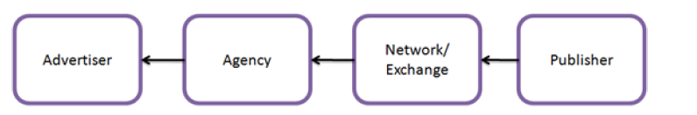

This is a simplistic view of the advertising industry which helps us understand the parties on the supply side and the demand side and the role of ad networks or ad exchanges.

**Basic terms in display advertising:-**

**Ad Impression -** An ad impression is a single viewing of a single ad by a single individual. Counting impressions is the method by which Web advertisement is accounted and paid for.

**Ad Inventory** – A collection of ad impression is known as ad inventory. It is actually the number of advertisements, or amount of ad space, a publisher has available to sell to an advertiser. Online ad inventory is often valued in terms of the site traffic or ad views that the publisher can deliver to the advertiser.

**CPC** – CPC stands for **Cost per click**. It is an internet advertising model where the advertiser pays the publisher when the ad is clicked. Clicks are a way to measure attention and interest. There are two primary models for determining pay-per-click: flat-rate and bid-based. In both cases, the advertiser must consider the potential value of a click from a given source. This value is based on the type of individual the advertiser is expecting to receive as a visitor to his or her website, and what the advertiser can gain from that visit, usually revenue, both in the short term as well as in the long term.

**CPI** – CPI stands for **Cost per Impression**. It refers to the cost of internet marketing where advertisers pay each time an ad is displayed. The risk associated with selling the inventory is minimal as the advertiser pays for only showing the ad and response of the customer is not taken in to account.

**CPM –** CPM stands for Cost per Mille or Cost per Thousand. Publishers mostly sell their inventory in Cost per thousand impressions.

## 2.1.5 Ad Exchange

**The problem with Ad Networks:**

The key challenge with being an ad network is that you have to grow the supply side of your business (the publishers) in parallel with the demand side (the advertisers) – there’s no point signing up a huge batch of new publishers if you’ve no one to sell their inventory to.

To solve this problem, the ad networks have brokered relationships with one another over the years so that, if a network has an impression that it needs to sell, but doesn’t have an advertiser to sell it to, it can sell that impression to another network. Similarly, in the reverse case, if a network has an opportunity to sell an ad, but doesn’t have the inventory to fulfill the sale, it can buy the inventory from another network.

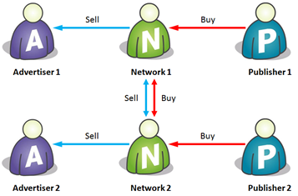

Fig. Relationship between networks

If there were just two or three ad networks in the world, this might not be a problem. But of course there aren’t – there are three hundred. But each ad network can’t have a relationship with every other ad network; each network would have to maintain 299 relationships, which comes to (299 + 298 + … + 2 + 1) = 44,850 relationships!!

**The Solution – Ad Exchange:**

Rather than the ad networks all dealing with each other directly, we need some kind of impartial intermediary which can act as a central hub through which the networks can trade. Such a central hub is an Ad Exchange. By adding an ad exchange into the picture, the trading relationships look as follows

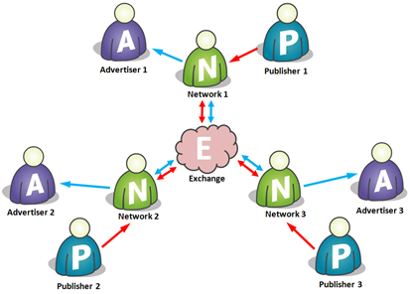

Fig. Trading relationship with an Ad Exchange

Now each ad network has just one trading relationship – with the exchange. So if there are 300 networks, there are 300 relationships, and every network is just one ‘hop’ away from every other network.

What this is means is that for a given ad impression on a publisher site, the network that owns that impression can say to the exchange, “what am I bid on this impression (one careful owner, full service history, nice neighborhood, good references)?”. The exchange can then hawk that impression to all the other networks and solicit bids. Depending on the data that is attached to the impression (or a cookie that one or more of the other networks may recognize and be able to attach data to), the various networks may be able to sell that impression for a greater or lesser amount. So the bids come in, the winning bid is selected, and passed back to the originating network; and if that bid is better than what the network could get from its own advertisers, it wins, and the ad is served.

**Advantages:**

* Crucially, there are only ever two networks (plus the exchange) in this transaction. So each network will take a cut of the impression price, and the exchange will charge a flat transaction fee (this is essential to maintain the exchange’s impartiality – taking a cut would introduce bias). Just having two networks in the transaction means more money for the networks and the publisher, and possibly better pricing for the advertiser. So everyone wins!!
* One of the irritating things about running an ad network is having to match demand to supply – as networks grow, they have to recruit both advertisers and publishers. The network model allows one-sided participants to flourish, dramatically increasing the range of ways in which businesses can participate in this market

In the below example, Network 2 doesn’t actually source any inventory direct from publishers – it gets it all from the network, and focuses on being great at selling that inventory to advertisers. Another (perhaps better) name for the kind of company that does this is a Media Agency

Example: Havas, Amazon, eBay

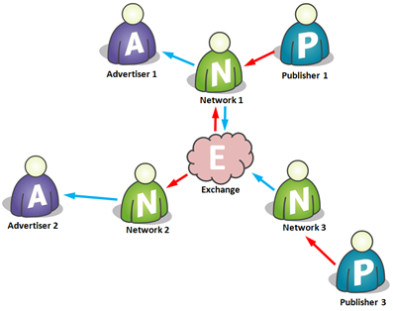

Fig. Media Agency and Sales House

Similarly, Network 3 above has decided to do away with its advertiser customer base and just sell all its inventory to the exchange. In this sense it becomes a bit more like an ad sales house or publisher aggregator than a true network.

Example: Six Apart

# 2.2 Demand Side

## 2.2.1 Demand Side Platform (DSP)

Demand-side Platforms are technology systems that let advertisers manage advertising inventory, maximize ad performance and pricing (through real time bidding) and consolidate user tracking (through various ad networks). Over the last year Real Time Bidding (RTB) has become the backbone of online advertising and this is why an advertiser needs a Demand side Platform. Before couple of years all these things were managed by Ad networks, however this left advertisers in dark where most of the times they did not actually know where they were advertising. The advantages of DSPs are:

* **Control through semantic targeting** – DSPs analyzes and categorizes the content of a website via semantic targeting before determining whether the content is appropriate for specific campaign.
* **Brand Protection** – DSP shows ads on only those webpages where it semantically understands the content. This protects the brand from displaying the ads on webpages with bad content.
* **Transparency** – Advertisers get a complete overview of their campaign data all the way down to URL level. This helps advertisers analyze ROI based on domain and URL.

**Examples** – Invite Media- it is acquired by DoubleClick, a subsidiary of Google Inc., Triggit.

2.2.2 Data Management Platform

A data management platform is a data warehouse. It is a software that collects, sorts and organizes information, and classifies them in a way that is useful for marketers, publishers and other businesses.

DMPs can be used to store and manage any form of information. DMPs help marketers in managing cookie IDs and in generating audience segments, which are ultimately used to target specific users with online ads. With the rise of ad tech, advertisers buy media across a huge range of different sites through various middlemen, including DSPs, ad networks and exchanges. It is all about better understanding of customer information.

A growing number of DSP providers now offer their clients DMP technology too. Those companies say it’s easier and more efficient for marketers to use one platform instead of two. The counter to that argument is that standalone DMPs make marketers’ data more portable, making it easier to feed into a wide range of DSPs.

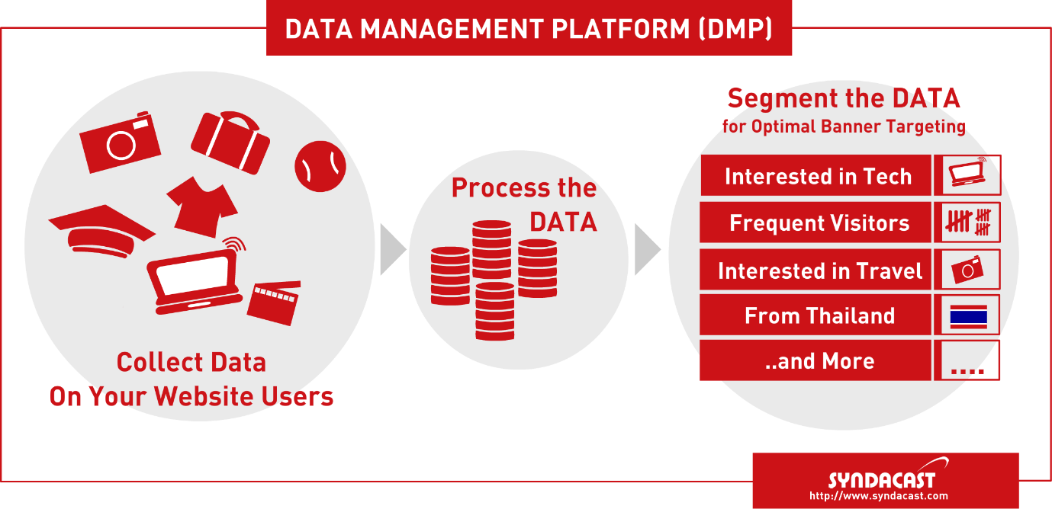

**Examples of DMPs:**

Vendors that sell DMP technology to the digital media world currently include Adobe, Krux, Lotame, Aggregate Knowledge, Blue Kai, Core Audience, Knotice, nPario and X+1. Some of those providers also offer DSP technology.

**Who uses DMPs?**

DMPs are used by agencies, publishers and marketers.

1. Agencies use the technology to collect and analyze the data collected from their client campaigns, which is sometimes pooled across multiple clients to create vast and rich datasets.
2. In an attempt to take closer control of their data, some clients have begun licensing their own DMP technologies and managing those platform themselves.
3. Meanwhile, a growing number of publishers are also making use of the technology as a way to help them better understand their reader information and extract more value from it as a result.

## 2.2.3 Planning & Attribution

**Media Planning:**

Media planning is generally the task of a [media agency](http://en.wikipedia.org/wiki/Media_agency) and entails finding media platforms for a client's brand or product to use. The job of media planning is to determine the best combination of media to achieve the marketing campaign objectives.

**Process:**

* Define the marketing problem. Where is the business coming from and where is the potential for increased business? Does the ad need to reach everybody or only a select group of consumers? How often is the product used? How much product loyalty exists?
* Translate the marketing requirements into media objectives. Must the ad reach people in a wide area? Then mass media, like newspaper and radio, might work. If the target market is a select group in a defined geographic area, then direct mail could be best.
* Define a media solution by formulating media strategies. For example, the rule of thumb is that a print ad must run three times before it gets noticed. Radio advertising is most effective when run at certain times of the day or around certain programs, depending on what market is being reached

**Examples:** WPP, Omnicom, Publicis etc.

**Attribution:**

Attribution is the process of identifying a set of user actions (“events”) that contribute in some manner to a desired outcome, and then assigning a value to each of these events.

Marketing attribution provides a level of understanding of what combination of events influence individuals to engage in a desired behavior, typically referred to as a conversion.

The purpose of marketing attribution is to quantify the influence each advertising impression has on a consumer’s decision to make a purchase decision, or convert.

**Advantages:**

* Visibility into what influences the audience, when and to what extent, allows marketers to optimize media spend for conversions and compare the value of different marketing channels, including paid and organic search, email, affiliate marketing, display ads, [social media](http://en.wikipedia.org/wiki/Social_media) and more.
* Typically, attribution data is used by marketers to plan future ad campaigns by analyzing which media placements (ads) were the most cost-effective as determined by metrics such as effective cost per action.

**Examples:** C3 metrics, Converto, Visual IQ.

## 2.2.4 Agency Trading Desk

There are various definitions, Forrester Research’s description follows:

* A centralized, service-based organization that serves as a managed service layer, typically on top of a licensed demand-side platform (DSP) and other audience buying technologies; **manages programmatic, bid-based media and audience buying.**
* Trading desk staff don’t just plan and buy media. They also measure results and report audience insights to their clients.

## 2.2.5 Dynamic Creative Optimization (DCO)

Dynamic Creative Optimization is the process in which the right banner is automatically generated in real time – with layout, products and messaging – based on a user’s shopping intent that is determined by our data mining engine

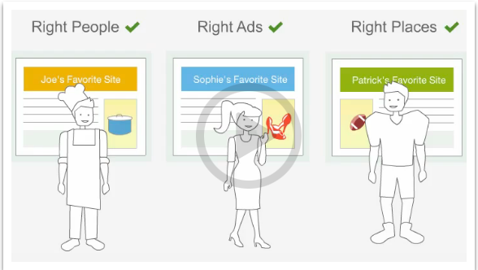

Instead of running a standard display ad that features a particular model of car, why not show an ad that adjusts to show the car model most appropriate to the particular user viewing the ad? Dynamic creative optimization does just that, by breaking an ad into individual elements, and creating versions of those elements relevant to different audiences, we enable you to create, and scale more personalized brand experiences.

Dynamic creating optimization can leverage following data sources:

* **Publisher data** including behavioral data which helps to identify the most appropriate audiences for your goals.
* **Reverse IP** which can be used for geo-targeting.
* **Advertiser data** which can be used for re-messaging.
* **Third-party data** including information about a customer's environment, such as stock market performance or local weather conditions.

The content, visuals and calls-to-action are then dynamically changed to deliver more relevant messages to that individual.

**Retargeting**

The user is identified by the cookie that gets generated, when he/she visits a website. Data suppliers provide the advertisers with the profile data of the user, so that they may target the user with specific ads. This process is known as targeting.

Further, the advertisers or the publishers can bring their own data about the users, that they may have maintained, particularly the data that identifies some kind of interaction of the user with the advertiser in the past. So, in this way, by clubbing the data the advertiser would be able to identify its users in a better way and can increase the number of conversions. This whole process is **Retargeting.**

Because of the much higher value to the advertiser, of reaching these users in particular, the publisher can sell that inventory at a higher price.

## 2.2.6 Advertising Agency

An advertising agency is a service based business dedicated to creating, planning and handling advertising for the advertisers. Creating an effective advertising campaign takes a great deal of time and effort. Most businesses do not have the creative talent and expertise to handle advertising campaigns in-house. Additionally, advertising agencies provide an outside prospective on the product being promoted, bringing with them objectivity that can't be found in an in-house marketing department. The various advantages of using ad agency are:

* **Expertise** – Many businesses turn to advertising agencies for their expertise and specialized knowledge. Small businesses, in particular, may not have their own marketing department, and so may need the depth of expertise an agency can provide.
* **Saving time -** Using an advertising agency can save a business valuable time. Hiring an advertising agency means that we do not need to spend time developing an advertising campaign. This is especially important if the staff are not dedicated to advertising work.
* **Saving Money -** Although it may seem as though hiring an advertising agency will be expensive, one needs to consider that an agency can save a lot of money on ad placement. Most agencies are given discounts by publishers, and radio and TV stations, so they can get cheaper rates than someone dealing directly. Agencies can also easily redesign ads to be more effective while taking up a smaller amount of space, saving more money.
* **Brand Development -** Even for experienced businesses, developing a brand can be a complex undertaking. Advertising agencies can help this process by developing logos and advertising that will develop brand awareness. They can also provide research that will allow target the most effective market. Agencies can also help design ads for individual media so that one can get the most effective advertising in each market.

Examples – WBB Group, Omnicom Group, Publicis Groupe

## 2.2.7 Advertiser’s Ad server

Before the coming of advertiser`s ad servers, the user would request the publisher for an advertisement, for which the publishers directed him to a completely separate server called publisher`s ad server, which acts as a repository of advertisements.

[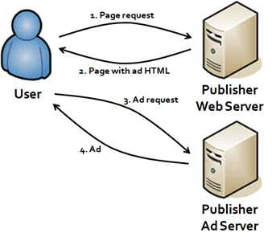](http://www.google.co.in/url?sa=i&rct=j&q=&esrc=s&frm=1&source=images&cd=&cad=rja&uact=8&docid=_cozIOfuPm0WaM&tbnid=JBgEJcnRj-VnCM:&ved=0CAUQjRw&url=http://www.liesdamnedlies.com/2008/06/online-advert-1.html&ei=7L7IU62oA8KJuATW7ID4BA&bvm=bv.71198958,d.c2E&psig=AFQjCNEP6BIarIGXKTisgfYBhud2c6aMMA&ust=1405751382847761)

So, the need to ask advertisers for an advertisement, to get it displayed each time, was eliminated. However, the advertisers were faced with some of the problems like:-

* They were not able to track their performance across multiple publishers
* Not able to decide pricing as they had no information about how many times an ad is served
* They could not vary the delivery rules of a campaign

To eliminate the above problems and provide more autonomy over advertising to advertisers, came the concept of advertiser’s ad servers.

It basically provides an advertiser with many functions like:-

1. Design a campaign for an ad and implement rules like frequency capping, ad rotation etc.
2. Tracking delivery of an ad across all sites.
3. Measuring the impact of an ad (number of clicks, conversions etc.)
4. Making any changes in the advertisements.

So, now the user request for an ad to publisher, who directs the user to publisher ad server, which redirects the user to advertiser`s ad server.

[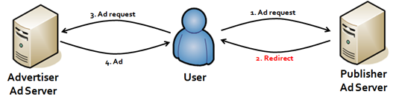](http://www.google.co.in/url?sa=i&rct=j&q=&esrc=s&frm=1&source=images&cd=&cad=rja&uact=8&docid=_cozIOfuPm0WaM&tbnid=pi8ih0ZBZMmnIM:&ved=0CAUQjRw&url=http://www.liesdamnedlies.com/2008/06/online-advert-1.html&ei=kMPIU5XfHMqwuAT_-YGQCQ&bvm=bv.71198958,d.c2E&psig=AFQjCNEP6BIarIGXKTisgfYBhud2c6aMMA&ust=1405751382847761)

Currently Microsoft/Atlas (with media console) and google/double click (with DFA) are the major players in advertiser’s ad server market.

Now a days, advertiser ad serves tend not to actually serve the ad, and have outsourced this task to CDN (Content Delivery Network) which maintain thousands of servers across Internet to serve ads on behalf of other people. This is done to simplify the process and maintain one to many relationships across web.

[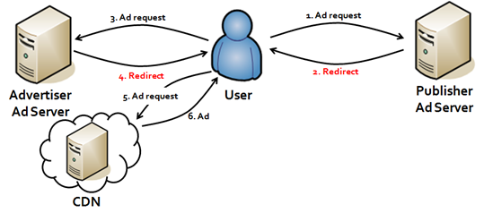](http://www.google.co.in/url?sa=i&rct=j&q=&esrc=s&frm=1&source=images&cd=&cad=rja&uact=8&docid=_cozIOfuPm0WaM&tbnid=7R-FrD3sfdApjM:&ved=0CAUQjRw&url=http://www.liesdamnedlies.com/2008/06/online-advert-1.html&ei=QsjIU8SeNZePuASW1IHICQ&bvm=bv.71198958,d.c2E&psig=AFQjCNFnk9K4ECL97dtX4HT1OdZW0r-kkA&ust=1405753790708415)

# 2.3 Supply Side

## 2.3.1 Supply Side Platform (SSP):

**What?**

* SSP is a platform that enables the publishers to manage their advertising impression inventory and maximize their revenue in digital media.
* It proves to be an efficient platform to tap into different sources of Advertisement (via Ad Networks, Ad exchange, Demand Side Platform- DSP).
* Thus it is able to provide an optimal Advertisement that maps directly to the publisher’s demand, maximizing publisher’s revenue.

**So how does SSP actually work?**

* SSPs allow publishers to connect their inventory to multiple ad exchanges, DSPs, and networks at once.
* This in turn allows a huge range of potential buyers to purchase ad space — and for publishers to get the highest possible rates.
* The idea is that by opening up impressions to as many potential buyers as possible — often through **real-time auctions** — publishers can maximize the revenues they receive for their inventory. Because of this, SSPs are sometimes referred to as yield-optimization platforms.

**What are the major supply-side platforms?**

Vendors that currently sell SSP technology include Google, OpenX, PubMatic, Rubicon Project, AppNexus, Right Media and AOL.

## 2.3.2 RTB

**What is Real Time Bidding (RTB) / Real Time Auction?**

* **Real-time bidding** (**RTB**) refers to the means by which ad inventory is bought and sold on a per-impression basis.
* With real-time bidding, advertisers bid on an impression and, if the bid wins, the advertiser’s ad is instantly displayed on the publisher’s site.